About
1 . xyz India with National Head Office at Pune has its network spread all over India to cater to the customer needs. A strong work force, especially trained in Japan helps provide total solutions to the customer. The Corporate spirit of Xyz runs in each person to keep challenging thru innovation to add value to your needs by the use of advanced technology. Our Technology center in Pune showcases the latest advanced solutions provided in India.
A highly energetic young team of xyz engineers engages into an in-depth understanding of your requirement before proposing solution, which actually will give you a sense of comfort and reassurance on your choice of partnering with xyz Our regional teams backed by HO come into action once the machine arrives at your place and you will be pleasantly surprised with the degree of perfection that each activity is carried out.

2. Established in the year 1989, we, Xyz are counted amongst the leading suppliers and exporters of a wide range of CNC control products, CNC controls and & servo drives metrology products. In addition, we also undertake efficient after-sales maintenance services/annual maintenance contracts ensuring smooth and trouble-free operations. Over the years, we have carved a special place for ourselves in the arena of industrial automation.

Our team works closely with the clients to understand their requirements and offer them customized technical solution in the field of process control and automation. Aiming at total customer satisfaction, we assure in offering you the most advanced industry automation solutions.

Under the able guidance of our founder Mr. abc, who has 20 years of valuable experience in automation and process control, CNCs, PLCs and Servo Drives, we have been to reach towards the hieghts of success.

3. The special thing of Xyz is its specialized designs of Pneumatic Conveying, Dust Control & Ventilation System, Grain Handling System for Distillery & Brewery, Flue Gas Cleaning System, Auto Weighing & Batching System” and respective equipments to fulfill requirements and need of the customer.
On the other hand, Xyz holds a specially chosen team of Engineers, Designers and technicians to maintain the selective qualities of our products viz. systems and other components. Also our skills for designs, procurement of associated equipments, project management and feasibility studies give full satisfaction to our customers. We have provided our services to various fields of industries like food, oil, Plastics, Pharmaceuticals, Chemical, steel and all other utility industries.

Services
- Our Service & Support staff can help you optimise your tool usage, look for ways to increase your productivity and reduce your costs.

- Superior equipment starts with top quality design, and Advent has the Experience & skills to provide all the Design & drawings and associated details for all its products and projects.
Xyz Design
- Total System Design
- Schematic Drawings
- Layout Drawings
- Construction Drawings
- Process and Instrumentation Drawings
- 2D and 3D CAD Facilities
- Fully detailed drawings and Design Qualification documents may be supplied to customer to confirm compliance with system

Contact

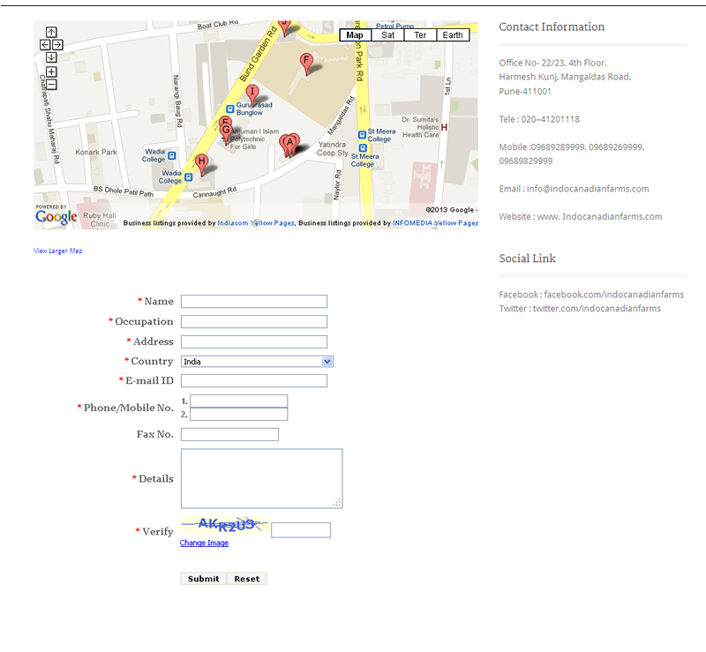

Disclaimer

This site is designed, updated and maintained independently by Vertex Infoservices (P) Ltd. All content on this site is the copyright of ADVENT ToolTech Pvt. Ltd..

The information contained in this Web site is intended, solely to provide general information for the personal use of the reader, who accepts full responsibility for its use. Kindly note that ADVENT ToolTech Pvt. Ltd. does not represent or endorse the accuracy or reliability of any information, including content or advertisements (collectively, the "materials") contained on, distributed through, or linked, downloaded or accessed from any of the services contained on this web site, or the quality of any products, information or other materials displayed, or obtained by you as a result of an advertisement or any other information or offer in or in connection with the service.

We accept no responsibility for any errors or omissions, or for the results obtained from the use of this information. All information in this site is provided "as is," with no guarantee of completeness, accuracy, timeliness or of the results obtained from the use of this information, and without warranty of any kind, express or implied, including, but not limited to warranties of performance, merchantability and fitness for a particular purpose. Nothing herein shall to any extent substitute for the independent investigations and the sound technical and business judgment of the reader.

In no event shall ADVENT ToolTech Pvt. Ltd. be liable for any direct, indirect, incidental, punitive, or consequential damages of any kind whatsoever with respect to the service, the materials and the products. The Users of this site must hereby acknowledge that any reliance upon any materials shall be at their sole risk.

The information presented here has been compiled from publicly aired and published sources. ADVENT ToolTech Pvt. Ltd.. respect these sources and is in no way trying to infringe on the respective copyrights or businesses of these entities.

ADVENT ToolTech Pvt. Ltd.. reserve the right, in their sole discretion and without any obligation, to make improvements to, or correct any error or omissions in any portion of the service or the materials. The information contained here in can be used for re-publishing and distribution only by taking written permission from ADVENT ToolTech Pvt. Ltd..
Privacy Policy
ADVENT ToolTech Pvt. Ltd.. has created this privacy statement in order to demonstrate our firm’s commitment to privacy. The following discloses our information gathering and dissemination practices for www.advent.com. We do not link IP address to anything personally identifiable. This means that a user’s session can be tracked, but the user will be anonymous. Our site’s registration form requires you to give us contact information like your name and email address. We use this contact information from the registration form to send you information about our company. Users may opt-out of receiving future mailings by choosing the unsubscribe option in the registration form.
This site may contains links to other sites. ADVENT ToolTech Pvt. Ltd.. is not responsible for the privacy practices or the content of such Web sites.

Security
This site has security measures in place to protect the loss, misuse, and/or alteration of information under our control. The data resides behind a firewall, with access restricted to authorized ADVENT ToolTech Pvt. Ltd.. personnel.

Opt-Out
Our site provides users the opportunity to opt-out of receiving communications from us at every point where we request information about the visitor.
If you have any questions about this privacy statement, the practices of this site, or your dealings with this Web site, you can contact us.

Facilities

We have with us well established CNC machine shop facility that is equipped with precision machining, milling and turning equipment which ably supports all involved in-process demands. With presence of CNC (computer numerical control) facilities, we are able to bring better optimization in productivity as well as match up with the exact specifications deatiled by the clients. Mostly the CNC machines have three axis (X axis, Y axis, Z axis), that helps in providing greater accuracy with better control over involved procedures, our CNC machine shop also has facilities for Vertical machining and Acne turning.

Here, the combination of driven tool lathes and sub-spindle allow us to effortlessly and rapidly carry out secondary operations like :
- Cross drilled holes
- Flats
- Hexagons
- Slots
- Internal threads
This helps us to achieve considerable reduction in terms of costs involved and production time. Further, these CNC machines are well handled by experienced support staff that allows us to deliver castings in fully machined conditions.
CNC Machining facilities form the inner base of operations and suit the working environments where customers require shortest lead times and a single source to cast, machine and finish components. Our well developed machining facilities indeed enhance the competitiveness of our customers by optimizing quality and productivity of involved processes.
Our team of experienced specialists efficiently handle the CNC Machining and casting processes and knows all the important aspects that are required to be kept in mind while working on casting components. They take due advantage of available machine tools including fastest and most versatile machines and ensure latest technology is employed to minimize production costs as well as enhance product quality.
Presently, we have well established CNC Machining Centres and CNC Turning facilities that add on to our capacity to accept largest castings. Here, we assure our customers of all machines having synchronized tapping so as to achieve maximum speed and threading accuracy.
Some USP’s of our CNC center include:
- Processes supported by standard and calibrated instrument for accurate inspection
- In-process inspection of critical dimensions
- CNC machine shop combined with conventional machining to ensure high accuracy and quality is delivered at competitive rates
- Maintaining precision machining standards
- Machine shop equipped with measuring instruments like CMM, assuring greater accuracies in the castings
The equipment range includes :
- Vertical Machining Center
- CNC Turning Center
- CMM (Coordinate Measuring Machine) (Equipped with fully motorized scanning probe capable for reverse engineering operations.)
The various machining processes employed in the manufacturing process are :
- Vertical Milling
- Horizontal Milling
- Turning
- Drilling
- Other related machining activities

